**Experiments 4 and 5: Practicing DDL Commands (Data Definition Language)**

The data definition language is used to create an object, alter the structure of an object and also drop already created object. The Data Definition Languages used for table definition can be classified into following:

(i) Create table command

(ii) Alter table command

(iii) Truncate table command

(iv) Drop table command

**QUERY:**

create database db;

use db;

create table employee

(emp_id int,

emp_name varchar(255),

sub varchar(255));

alter table employee

add primary key(emp_id);

desc employee;

select * from employee;

insert into employee values(100,'chandrashekar','DBMS');

insert into employee values(101,'Nagamani','OS');

insert into employee values(102,'Rojarani','BEFA');

insert into employee values(103,'BapiRaju','JAVA');

insert into employee values(104,'Nagaveni','DM');

truncate table employee;

select * from employee;

drop table employee;

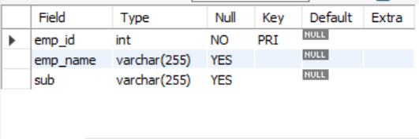

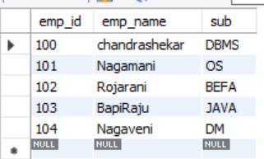 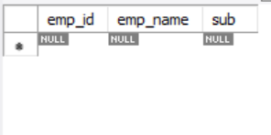

Output after creating table Output after truncate command